OUR OWN HIGH SCHOOL AL WARQA’A
GRADE -9 IMPORTANT QS FROM POEMS FOR SA1
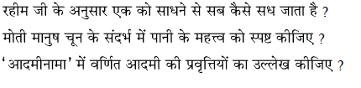
1
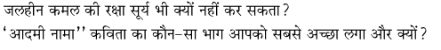
2
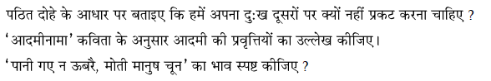
3
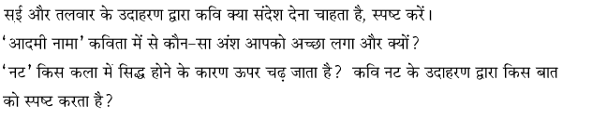
4
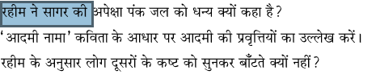
5
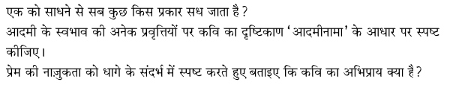
6

