Practice Worksheet 1
CBSE
Subject : Biology (How do organisms reproduce?)
Name: Grade: 10 Sec:
___________________________________________________________________________
- List the differences between pollination and fertilisation.
- Name the information source for making proteins. In what respect is the human male gamete different from the female gamete?
- Plants like rose, banana and jasmine are grown by vegetative means. Why?
- How does sexual reproduction help in maintaining the chromosome number of a species constant from generation to generation?
- What is the function of stigma?
- What is meant by DNA copying? Mention its importance in reproduction.
- (a) Draw a labelled diagram of longitudinal section of flower
(b) Name the male and female reproductive part in a bi-sexual flower. Explain the function of each in brief.
- (a) Draw a labelled diagram of germination of pollen on stigma and label – Stigma, Pollen grain, Male germ cell and Female Germ Cell.
(b) Explain the process of germination.
- (a) List any two methods of asexual reproduction.
(b) Explain how spirogyra reproduces?
- Explain the phenomenon of regeneration with the help of a diagram. How is regeneration different from reproduction?
- Fallen leaves of “Bryophyllum “on the ground produce new plants whereas the leaves of rose do not? Explain this difference between the two plants.
- (a) How do organisms reproduce by fission? Write names of any two organism which reproduce by this method.
(b) Differentiate between the fission of Leishmania and Plasmodium.
- With a set of suitable diagram, describe the process of budding as seen in yeast.
- What happens when a pollen grain falls on the stigma?
- (a) What is meant by vegetative propagation?
(b) How will a plant be benefitted if it reproduces by vegetative propagation? Mention the advantages.
- Draw diagrams showing binary fission in Amoeba. Give an example of an organism which reproduces by multiple fission.
- Why papaya flowers are called unisexual?
- After fertilization in a flower, mention the structures that develop into the embryo, fruit and seed.

- Identify the organisms and the mode of asexual reproduction exhibited by them.
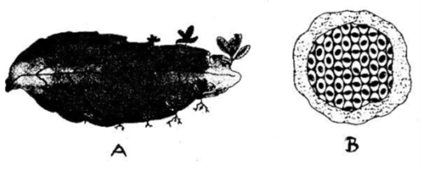
- How will an organism be benefited if it reproduces through spores?
- Name the two asexual methods by which hydra can reproduce.
- (a) List two advantages of sexual reproduction over asexual reproduction.
(b) Name the type of asexual reproduction seen in: (i) Plasmodium (ii) Planaria
- (a) Draw a diagram of Rhizopus showing the location of: (i) Sporangium (ii) Rhizoidal hyphae.
(b) Explain spore formation.
- (a) Distinguish between self-pollination and cross-pollination.
(b) How does fusion of male and female gametes take place in plants?
- List two suitable differences between pollen grain and ovule.
- Give any two suitable differences between Radicle and Plumule.
- Name any two plants that reproduce by Grafting.
- With the help of suitable diagrams explain how reproduction occurs in Planaria. Also name the process involved.
- Differentiate between binary and multiple fission. Name an organism that reproduces by multiple fission.
- (a) Draw a neat labelled diagram of a germinated seed and label radicle, plumule and cotyledon.
(b) Mention function of each of these parts.
- What is pollination? How does it takes place?
- (a) Differentiate between unisexual and bisexual flowers. (b) Which of the following plants produce unisexual flower? Watermelon, Hibiscus, Mustard, papaya.
- (a) Name the process by which transfer of Pollen grains transfer from anther to stigma. Mention any one external agent which performs this process in some flowers.
(b) Differentiate between its two types. Give one example for each.
- "Multicellular organisms cannot divide cell by cell". List two reasons to justify this statement.

______________

